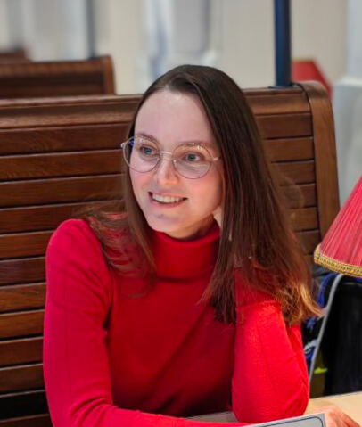
Marina Kovaleva
Pelvikveien 1A, 1367 Snarøya | +47-453-909-66 | owlet.savvina@gmail.com

Profile
Detail-oriented IT professional with experience in software testing and quality , now advancing into software development through the Front-End Developer program at Noroff School of Technology. Passionate about building user-centered digital services, with a focus on UI/UX design and intuitive interfaces.

Key Skills
- Tools & Platforms: Figma, Jira, Azure DevOps, TestRail, QASE, Git, VS Code
- UI/UX & Front-End Development: User-centered design, creating intuitive and visually appealing interfaces, prototyping, responsive web design, HTML, CSS, JavaScript, React (in progress, Noroff program)
- Testing & QA: Functional, Regression, GUI, UAT, Test Automation basics, ensuring high-quality and user-friendly applications
- Methodologies: Agile/Scrum practices, SSDLC knowledge, experience collaborating in cross-functional teams
- Languages: English (Upper-Intermediate), Norsk (Upper-Intermediate), Russian (Native)

Education
Noroff School of Technology, Oslo (2024–2026)
Front-End Development program
State University of Telecommunications, St. Petersburg, Russia (2008–2014)
Engineer’s Degree, Multichannel Telecommunication Systems
(Norwegian approval obtained)

Relevant Experience
Freelance IT Tester (uTest, crowd platforms) – Jan 2023–2024
- Tested mobile and web applications with a focus on usability and user experience
- Provided structured feedback on UI design, interaction flow, and accessibility
IT Tester (Contract), Simli Ltd, Oslo – Oct 2022–Dec 2022
- Evaluated VR app interfaces on Android/iOS for intuitive navigation and user engagement
- Collaborated closely with developers to improve UI/UX

IT Quality Control Engineer/Test Leader, SoftDev Ltd (Russia) – 2014–2019
- Led a team of 8 testers across 4 projects (TurboCAD, AutoPLANT).
- Designed Test Plans, developed test documentation, analyzed risks.
- Mentored junior engineers and optimized workflows.

Additional Projects & Volunteering
- Board Member (HSE), Sameiet Pelvikveien 1 (2024–present)
- Graphic Designer/Digital Illustrator, Duepatruljen (2024–present)
- Graphic Designer/Digital Illustrator. Multiskole Parmenova Ltd (Norway) (Aug 2021– Sep 2023)

- Test Engineer, Krasiviy Peterburg NGO (Russia) – development & testing of a civic tech app, improving usability and user-centered functionality (2020–2022).

